

Version: 4.2.0

Published date: January 2024

Copyright © 2024 by ESW. All rights reserved. Information contained herein is subject to change without notice.

Return Merchandise Authorization (RMA) INTEGRATION GUIDE



**SFCC - ESW Cartridge**

+

Contents

**1** **Return Merchandise Authorization** 2

* 1. eShopWorld Order Return (ESW => SFCC) 3

1.1.1 ESW Webhooks Configuration 3

1.1.2 Workflow to Return Order in SFCC 4

**2** **Order Return Integration Configuration** 4

2.1 Import Metadata 4

2.2 EswOAuthService 4

# **Return Merchandise Authorization**

ESW plugin allows retailers to return order from SFCC or ESW panel. In both cases the cartridge will maintain the order synchronisation so that upon mark an order as return from SFCC or ESW it will be mark as return on both places.

In short, the ESW-SFCC cartridge allows retailers to synchronize returned order in both ways ESW => SFCC and SFCC => ESW.

* 1. eShopWorld Order Return (ESW => SFCC)

The ESW-SFCC Cartridge allows retailers to cancel orders in SFCC if order cancelled via ESW CSP first.

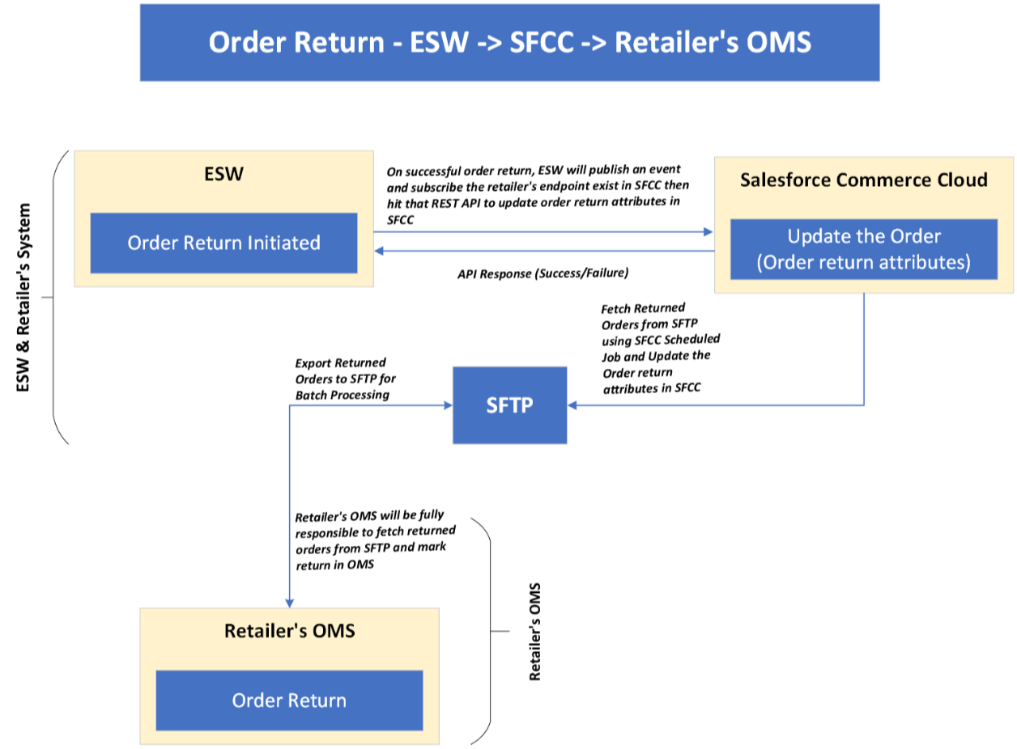

* + 1. ESW Webhooks Configuration

Retailers need to subscribe SFCC API endpoint in ESW tenant configuration that will trigger on OrderReturnSucceedEvent. The ESW-SFCC cartridge provides the OOTB SFCC endpoint to subscribe with ESW order cancellation webhook event. ESW integration engineer can help retailers to subscribe this endpoint.

**SFCC Endpoint Example:**

[https://example.com/on/demandware.store/Sites-RefArch-Site/default/EShopWorld-](https://example.com/on/demandware.store/Sites-RefArch-Site/default/EShopWorld-CancelOrder)ProcessWebHooks

Retailers can update example.com with their storefront domain.

* + 1. Workflow to Return Order in SFCC

The ESW-SFCC Cartridge perform the following to cancel order in SFCC If order cancelled from ESW CSP first to sync order status in both systems.

* On successful order cancellation in ESW CSP, webhook will trigger the retailers provided subscribed SFCC endpoint (EShopWorld-ProcessWebHooks) with returned order detail in request body.
* SFCC endpoint will park cancelled order data in SFCC custom objects **eswRmaJson** and make **eswIsReturned** as true like below.

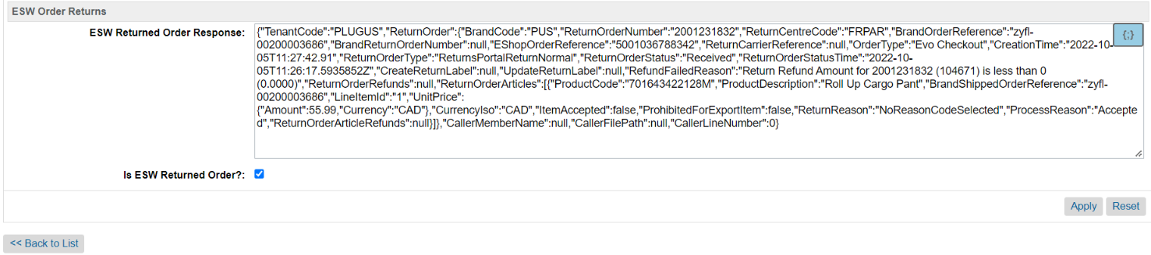

# **Order Return Integration Configuration**

* 1. Import Metadata

Import order level custom attributes (systemobjects.xml) from **link_eshopworld\sitesdata\meta.**

The following **ESW Order Returns** custom attributegroup will be present in Order Custom Attributes:

* **ESW Return Order Response**: This custom attribute will be filled with transaction reference if order successfully or even unsuccessfully returned in ESW and this will be in ESW Order API response.
* **Is ESW Returned Order?**: This mark order as return.
  1. EswOAuthService

This service is used to get the authentication token from ESW. This token is used by other ESW services and APIs, such as Price Feed, Checkout, and Package.

Services can Import service from **link_eshopworld\sitesdata\services.xml**

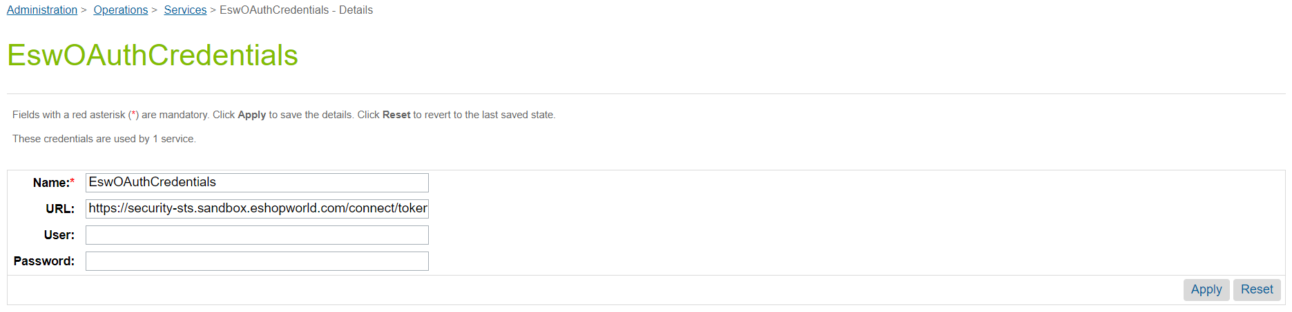

*ESW OAuth Credentials*